Western Pacific University
CMN 244 / CMP 244 Software Engineering – Week 5
Lab 4: Architecture & UML for Your Client
Part A – Answer the six design questions
Kina Ridge Primary School
# | Question | Decision, and the requirement that forced it
1 | What are the major parts of the system? | A major part of the system will include the enrolment and student records, fee/payment and report cards.
2 | How do the parts communicate? | All the users will communicate through the application services, then will success the database. Thus, it will separate the business logic from the storage.
3 | Where does the data live? | The data will be stored in the database local SQLite via the laptop
4 | Where does each part physically run? | The user interface will run on the laptop, while the application and the database will operate on the administration computer
5 | How is access controlled, and where is that enforced? | The users will have their own account to login; the access control will be enforced on the application logic layer to allow the different permissions from the administrators
6 | What happens when it fails — power loss, no signal, duplicate sync? | The system will continue to work using the offline local storage and will be sync later during black outs

Part B – Choose an Architectural pattern
- Pattern Choose: Offline-First Client-Server Architecture
Justification:
Kina Ridge Primary School requires a system that can continue operating when the internet connection is unstable. Offline-First Client-Server architecture is the most suitable because it allows the teachers, staffs to register students, record attendance and manage fee payment using a local application and database. All the records and information are stored locally on a database and will sync to a central database when the network connectivity is available. The architecture balances the local database with a centralised data management.
Part C – Draw the package diagram
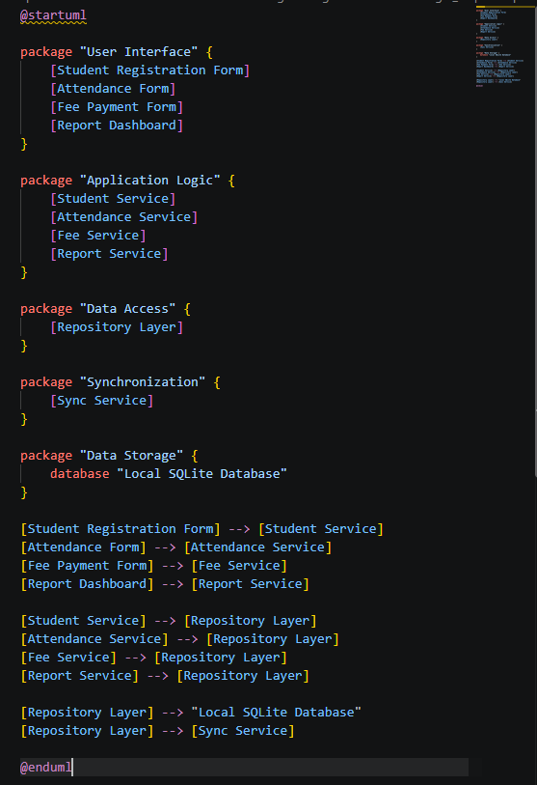
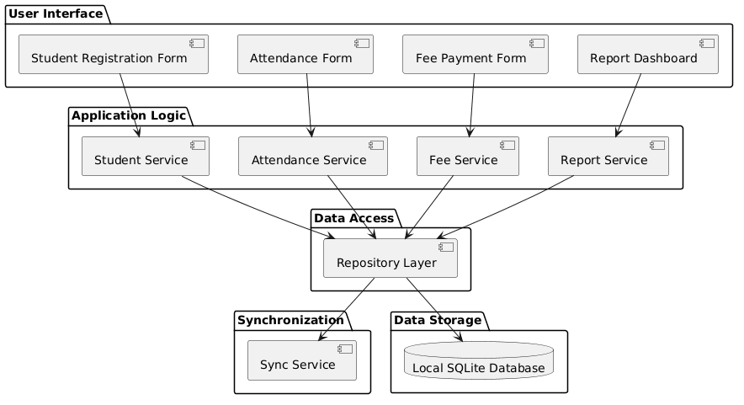
Part D – Draw the deployment diagram
